Net 1061 Switching, Routing, and Wireless Essentials

Name:

Lab: #

Follow the instructions down below for the lab itself. For this lab, all answers need to be in blue font. For the questions right below, answer in complete sentences. If this is a self-grading packet tracer. Ensure you paste the screen shot of your score page at the bottom of the document. You will upload both this document and the pkt file regardless if it is self-grading or not. Let the instructor know if you have any questions.

Lab Analysis Report

1. Using complete sentences summarize work you completed during the lab.
In this lab, I first created the VLANs and assigned the ports to them. Then, configured the subinterfaces on the router. Then, I enabled trunking on the switch. Finally, I verified connectivity.

2. Using complete sentences describe what you learned from the lab. Hint; look at the lab objectives listed at the top of the lab section.
In this lab, I learned how to configure router-on-a-stick. I learned the show vlan command.

Problems Encountered

1. Using complete sentences describe any problem(s) experienced during lab.
I didn’t experience any problems.

2. Using complete sentences describe how you solved your problem(s).

3. Using complete sentences explain if you needed any assistance with the lab; then list what you learned from that assistance.

Packet Tracer - Configure Router-on-a-Stick Inter-VLAN Routing

Addressing Table
Device | Interface | IPv4 Address | Subnet Mask | Default Gateway
R1 | G0/0.10 | 172.17.10.1 | 255.255.255.0 | N/A
R1 | G0/0.30 | 172.17.30.1 | 255.255.255.0 | N/A
PC1 | NIC | 172.17.10.10 | 255.255.255.0 | 172.17.10.1
PC2 | NIC | 172.17.30.10 | 255.255.255.0 | 172.17.30.1
Blank Line - no additional information

Objectives
Part 1: Add VLANs to a Switch
Part 2: Configure Subinterfaces
Part 3: Test Connectivity with Inter-VLAN Routing

Scenario
In this activity, you will configure VLANs and inter-VLAN routing. You will then enable trunk interfaces and verify connectivity between VLANs.

Instructions

Add VLANs to a Switch

Create VLANs on S1.
Create VLAN 10 and VLAN 30 on S1.
Open configuration window

Assign VLANs to ports.
      - Configure interfaces F0/6 and F0/11 as access ports and assign VLANs.
- Assign the port connected to PC1 to VLAN 10.
- Assign the port connected to PC3 to VLAN 30.
      - Issue the show vlan brief command to verify VLAN configuration.
S1# show vlan brief

VLAN Name Status Ports
---- -------------------------------- --------- -------------------------------
1 default active Fa0/1, Fa0/2, Fa0/3, Fa0/4
Fa0/5, Fa0/7, Fa0/8, Fa0/9
Fa0/10, Fa0/12, Fa0/13, Fa0/14
Fa0/15, Fa0/16, Fa0/17, Fa0/18
Fa0/19, Fa0/20, Fa0/21, Fa0/22
Fa0/23, Fa0/24, Gig0/1, Gig0/2
10 VLAN0010 active Fa0/11
30 VLAN0030 active Fa0/6
1002 fddi-default active
1003 token-ring-default active
1004 fddinet-default active
1005 trnet-default active
Close configuration window

Test connectivity between PC1 and PC3.
From PC1, ping PC3.

Question:
Were the pings successful? Why did you get this result?
No, a router is needed to be successful.Type your answers here.

Configure Subinterfaces

Configure subinterfaces on R1 using the 802.1Q encapsulation.
Open configuration window
      - Create the subinterface G0/0.10.
- Set the encapsulation type to 802.1Q and assign VLAN 10 to the subinterface.
- Refer to the Address Table and assign the correct IP address to the subinterface.
R1(config)# int g0/0.10
R1(config-subif)# encapsulation dot1Q 10
R1(config-subif)# ip address 172.17.10.1 255.255.255.0
      - Repeat for the G0/0.30 subinterface.

Verify Configuration.
      - Use the show ip interface brief command to verify subinterface configuration. Both subinterfaces are down. Subinterfaces are virtual interfaces that are associated with a physical interface. Therefore, in order to enable subinterfaces, you must enable the physical interface that they are associated with.
      - Enable the G0/0 interface. Verify that the subinterfaces are now active.
Close configuration window

Test Connectivity with Inter-VLAN Routing

Ping between PC1 and PC3.

Question:
From PC1, ping PC3. The pings should still fail. Explain.
Trunking has not been enabled yet.Type your answers here.

Enable trunking.
Open configuration window
      - On S1, issue the show vlan command.

Question:
What VLAN is G0/1 assigned to?
The default VLAN.Type your answers here.
      - Because the router was configured with multiple subinterfaces assigned to different VLANs, the switch port connecting to the router must be configured as a trunk. Enable trunking on interface G0/1.

Question:
How can you determine that the interface is a trunk port using the show vlan command?
If the port isn’t listed under a VLAN.your answers here.
      - Issue the show interface trunk command to verify that the interface is configured as a trunk.
Close configuration window

Test Connectivity
If the configurations are correct, PC1 and PC3 should be able to ping their default gateways and each other.

Question:
What addresses do PC1 and PC3 use as their default gateway addresses?
PC1 uses 172.17.10.1. PC3 uses 172.17.30.1.
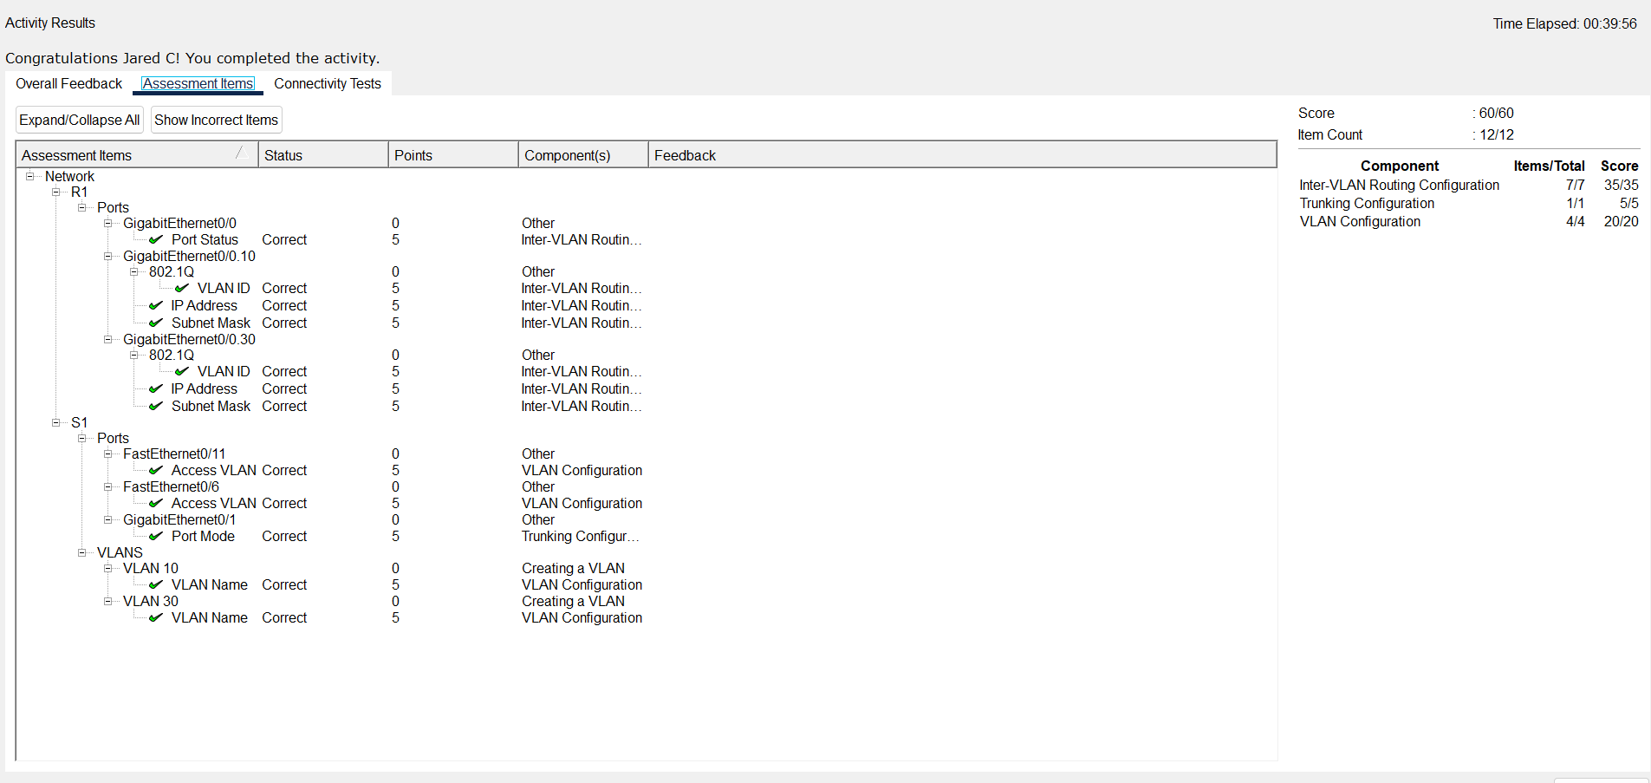Type your answers here.
end of document

